**Pre-Lab 01**

Emre Can Şen - 21902516

*Department of Electrical and Electronics Engineering, Bilkent University, 06800 Ankara, Turkey*

1. **Introduction**

In this lab, real life engineering problems are tackled. Firstly, Nabucco pipeline project is examined and different parameters of the project that are crucial for the success of the project are determined and location of the gas tank is decided based on these parameters. Possible engineering and non-engineering problems that might arise during the project and their solutions are discussed. Finally, theoretical linear approximation of the gas tank system with its properties are obtained.

1. **Laboratory Content**

**Question 1**

First thing to consider is the geographical location of the gas storage tank. From the first figure, the path of the pipeline can be seen and the gas tank should be close to this path. Since extensive distance from the pipeline will increase the cost.

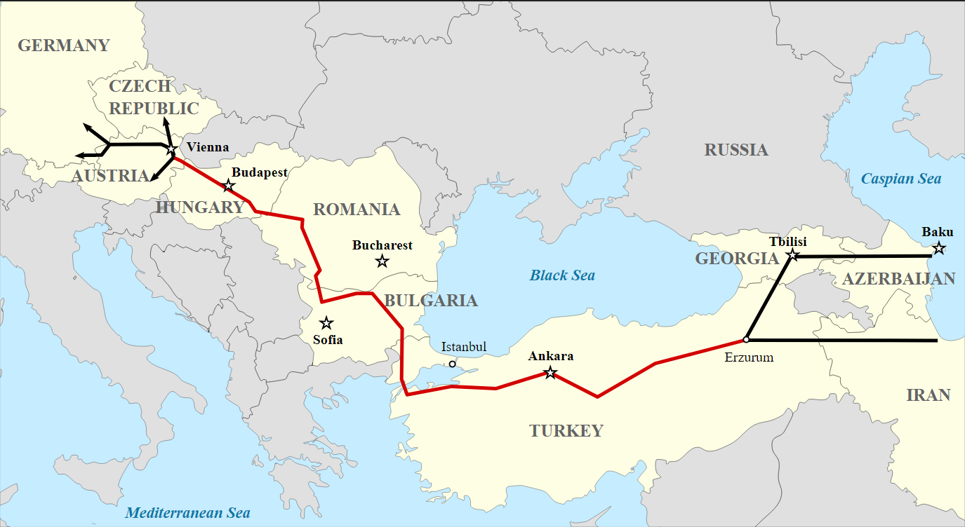

Figure 1- Nabucco Pipeline Project Route [1]

Secondly, the storage method should be considered. The most common way to store natural gasses are underground storage facilities [2]. These storage facilities commonly store the gasses in depleted fields, salt formations or depleted aquifers [3]. So the chosen location should at least have one of these formations with sufficient storage capacity, sufficient depth and recoverable gas amount [4].

Thirdly, the availability of natural gas pipeline infrastructure is needed to connect the storage to main pipeline. In figure 2, the gas pipeline routes of Turkey are given. It is critical to consider this map as unavailability of pipeline infrastructure will increase the costs significantly.

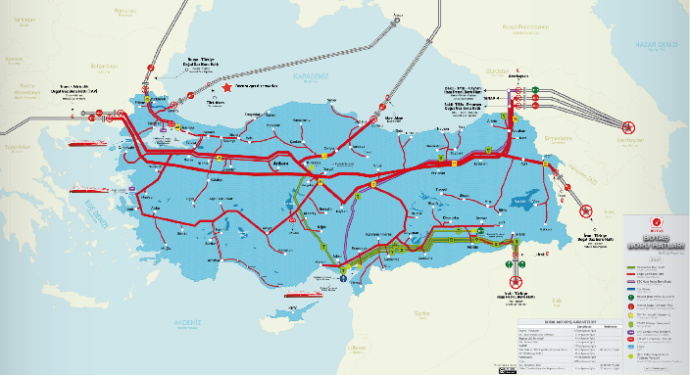

Figure 2- Turkey Gas Pipeline Routes [5]

One other aspect is that facility should be built in vicinity to sufficient population to be able to sustain the facility. There should be enough work force that can be supplied to the facility. Where its built should be logistically suitable too. In cases of pipeline or storage failures, facility should be able to receive support.

Lastly, earthquakes might pose a threat to the facility. In figure 3, the fault line map of Turkey is given and these redder areas should be avoided since earthquakes increase health security and cost risks.

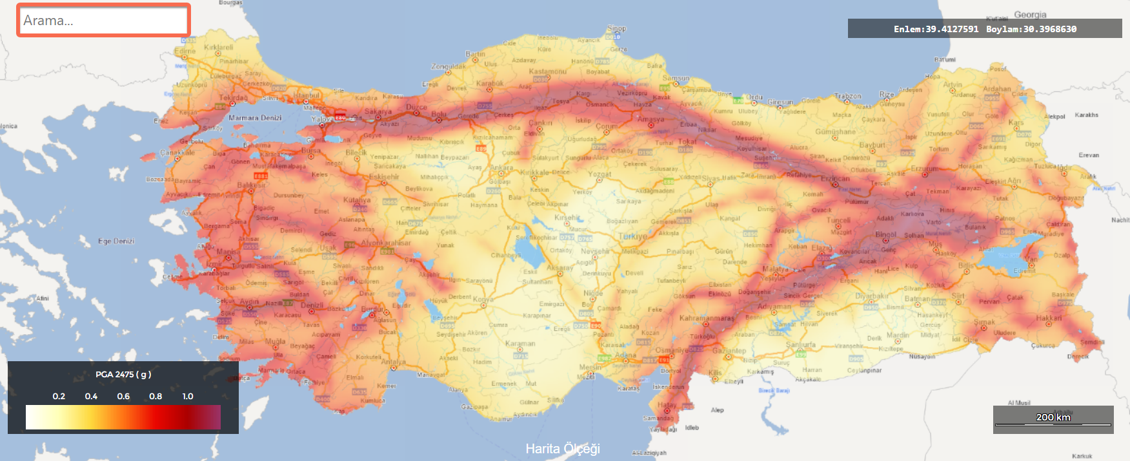

Figure 3- Turkey Fault Line Map [6]

After considering all these parameters, the gas storage tank location is chosen as Aksaray. Aksaray is close to both Nabucco pipeline and available gas pipeline routes. It also has sufficiently large population to sustain the facility. Aksaray is also one of the safest places in Turkey in terms of earthquakes. There are also abundant of suitable locations with sufficiently large salt caverns near Tuz Gölü which is in Aksaray.

**Question 2**

First engineering problem might be regarding maintaining the gas pressure constant throughout the pipeline. When the pipeline is extended to the gas storage tank location, keeping the pressure stable might be a problem. Also the pipeline goes across countries and that might be a challenge too. So barometers with control valves might be set up with certain intervals. Second engineering problem might be related cavern gas leakages. There are some standardized [4]. So the facility should be tested according to these standards.

First non-engineering problem might be related with the relations between countries. Since this is a multi-national project, keeping relations between countries stable is one of the most crucial aspects.

Second non-engineering problem might be about the local community. Specifically, the community might not be suitable to work in the facility. There might not be a workforce that has work experience in this industry. So they can be given special trainings to be able to work in this field.

**Question 3**

The first step of this part is to determine the given parameter values according to our ID numbers.

Using the conservation of mass equation, it is found that:

In the above equation stands for the density of the gas. Then the and equations are plugged in that are given in the manual to the above equation:

The next step is to linearize this equation in order to take Laplace transform to find the transfer function in the following steps.

Then equilibrium point t=0 is plugged into the function.

Next step is to find these terms and plug them into the equation:

Then all of the terms are plugged in:

Then the equation is rewritten to find the transfer function:

Then the given controller in the manual is plugged into The roots of the denominator must be in the LHP:

So the parameters were chosen as: a=2, b=3, K=100. Then the poles of the closed loop system are found as -, -0.01619-0.35653i and -0.01619+0.35653i. All poles are in LHP, so the system is stable. Then is found:

Then the bode plot of the closed loop system is plotted with MATLAB:

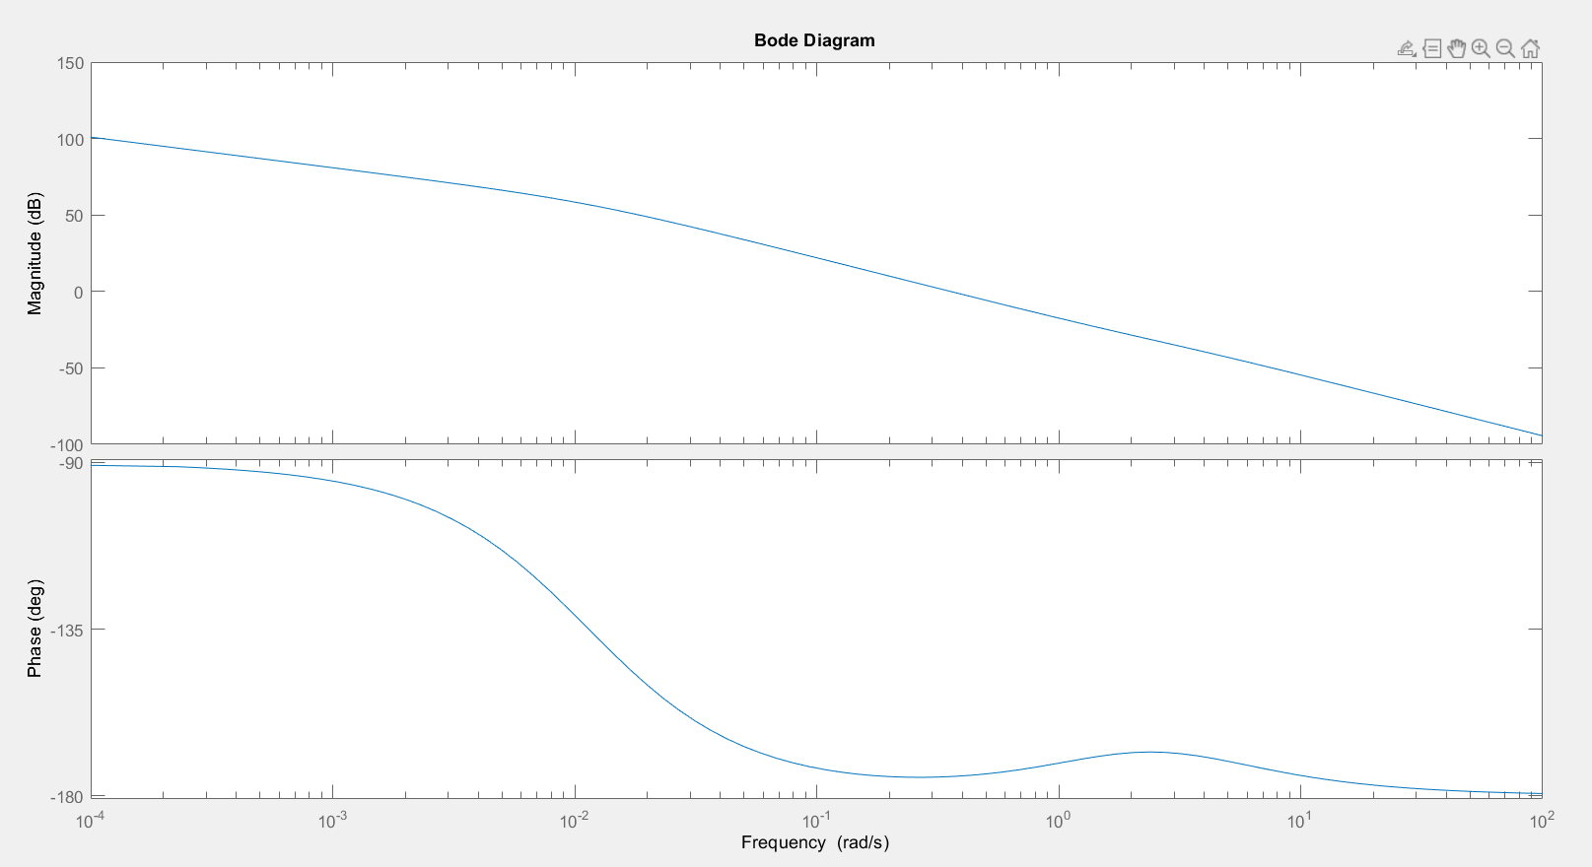

Figure 4- Bode Plot of the System

From the plot it can be seen that the plot never reaches

-180 degrees. So the gain margin of the system is infinite. Then the 0dB point is determined from the plot:

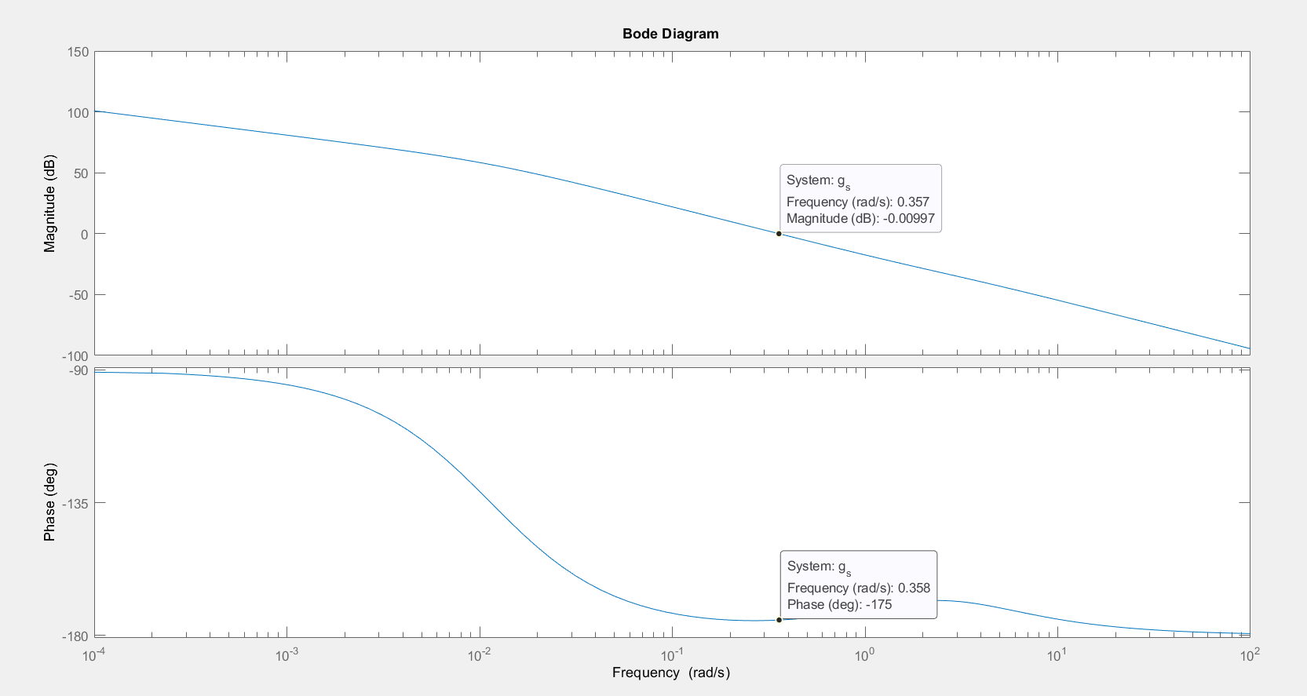

Figure 5- Phase and Gain Margin

The point where 0dB was reached had angular frequency of 0.357 rad/s. Then the phase at the point at 0.357 rad/s was -175 degrees. So the phase and delay margins are:

1. **Conclusion**

After considering all of the parameters presented that was crucial for the project, Aksaray was chosen for the suitable gas tank location. Then two engineering and two non-engineering problems that might be encountered during the project were determined and possible solutions were proposed. Finally, a theoretical linear model of the gas tank was derived. Then a stable controller was designed, and gain, phase and delay margins of the system were computed with the help of the Bode plot.

**REFERENCES**

1. “Nabucco pipeline,” *Wikipedia*, 08-Oct-2022. [Online]. Available: https://en.wikipedia.org/wiki/Nabucco_pipeline. [Accessed: 02-Dec-2022].
2. “Underground Natural Gas Storage,” *Home*. [Online]. Available: https://www.energyinfrastructure.org/energy-101/natural-gas-storage. [Accessed: 02-Dec-2022].
3. “Natural Gas Storage,” *Wikipedia*, 17-Nov-2022. [Online]. Available: https://en.wikipedia.org/wiki/Natural_gas_storage#Types. [Accessed: 02-Dec-2022].
4. “Documents & Reports - all documents: The World Bank,” *World Bank*. [Online]. Available: https://documents.worldbank.org/en/publication/documents-reports. [Accessed: 02-Dec-2022].
5. “Turkey: A new emerging gas player with resources and infrastructure,” *Middle East Institute*. [Online]. Available: https://www.mei.edu/publications/turkey-new-emerging-gas-player-resources-and-infrastructure. [Accessed: 02-Dec-2022].
6. “Türkiye Cumhuriyeti Vatandaş Kimlik doğrulama sistemi,” *e-Devlet Kapısı*. [Online]. Available: https://tdth.afad.gov.tr/TDTH/main.xhtml. [Accessed: 02-Dec-2022].

**Appendix**

a=87.950748;

k=10;

b=0.1668426;

sys=tf([k*b,k*b],[a,2*a+1,2,0]);

p=pole(sys);

c=100*0.1668426;

g_s=tf([c,2*c],[a,3*a+1,3,0]);

bode(g_s)